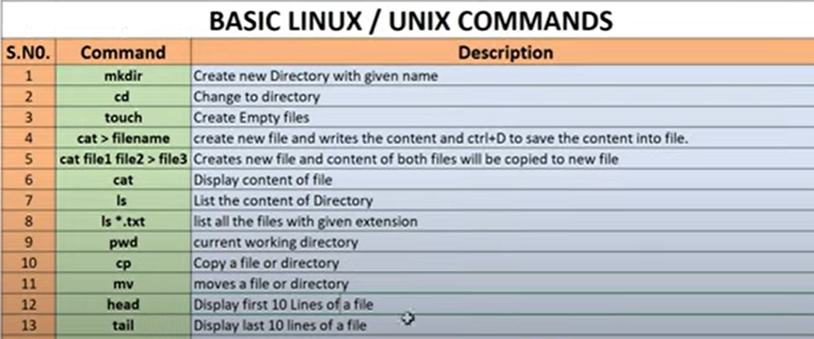

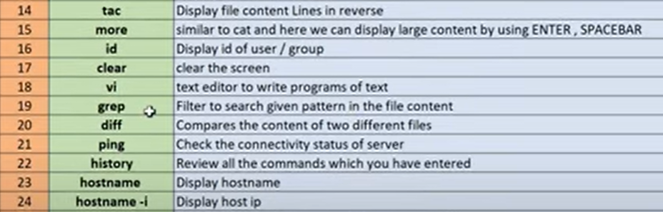

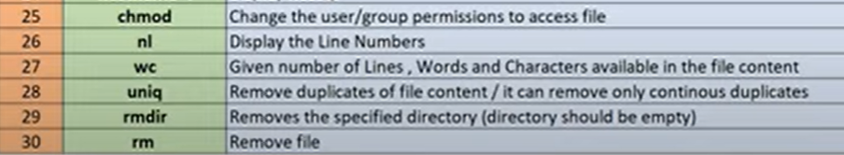

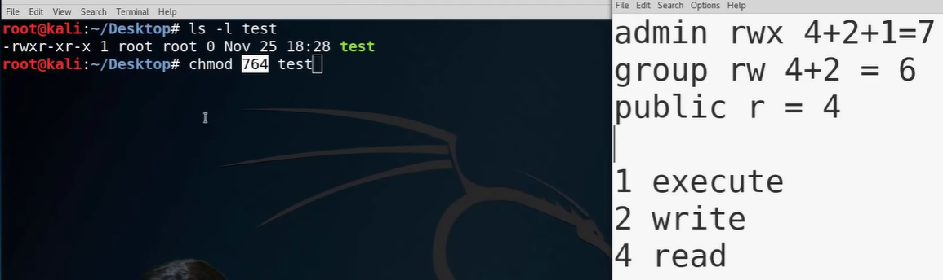

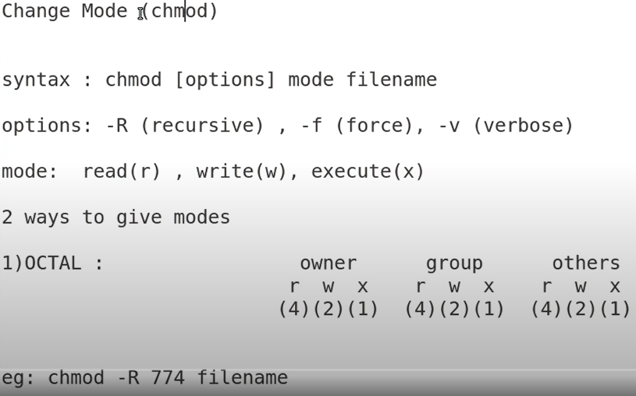

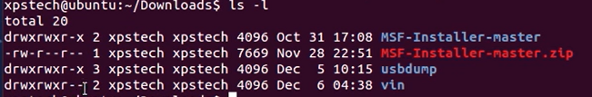

First Letter

d (stands for directory)

- (stands for file)

First xpstech is the owner

Second xpstech is the group

**GREP (GLOBAL REGULAR EXPRESSION PRINT)**

**Assume a names.txt file and we need to find John Williams in the file**

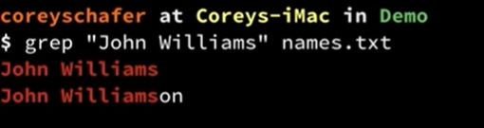

**If you see you get John Williamson as well in the result**

**If we only want the specific word we need to pass -w flag**

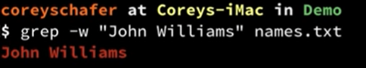

**Note : GREP is case sensitive so we will need to pass – I as a flag as well if we want to ignore casing**

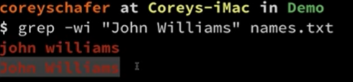

**If you want the line numbers as well along with the text add -n flag**

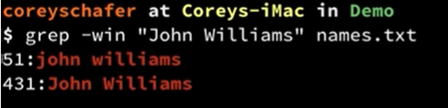

**If you want to see 4 lines before the match use -B Flag with the number of lines specified**

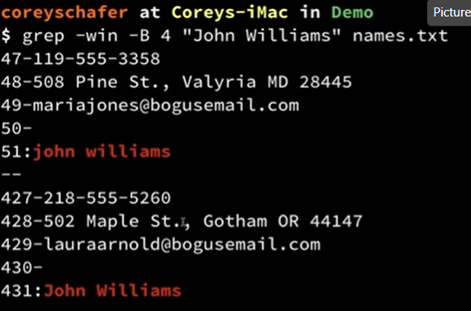

**If you want to see 4 lines after the match use -A Flag with the number of lines specified**

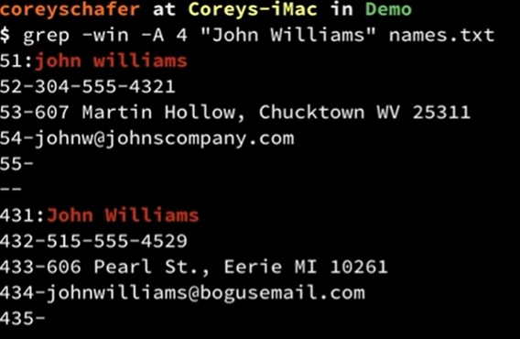

**If you want to see few lines before and after the match use -C Flag with the number of lines specified**

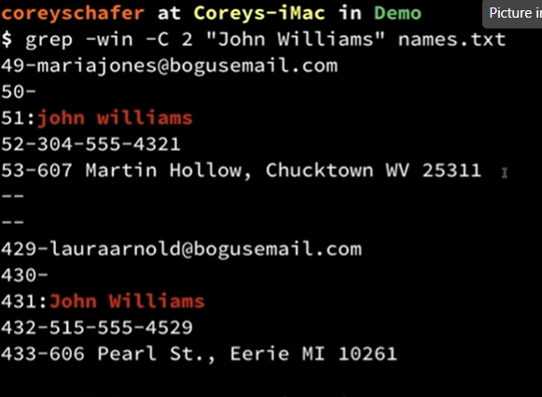

**Find a text in any text file in a directory**

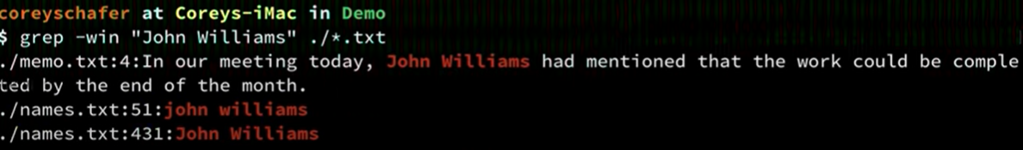

**Find a text in any text file in a directory and sub directory . As you can see below it searched the sub directory as well we need to use -r flag**

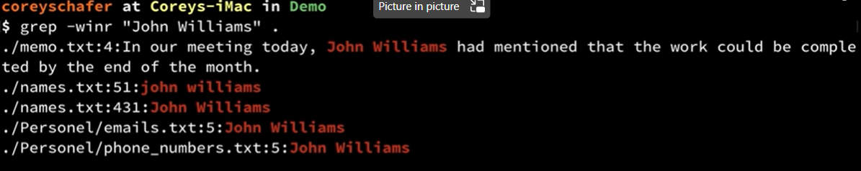

**If you are interested in only finding the names of the file in which this word you are searching exists then use the – l flag and remove – n flag because we don’t need the line number anymore**

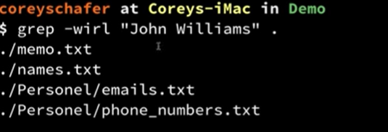

**If you are interested in only finding the names of the file and the number of times the word you are searching exists in them then use -c flag**

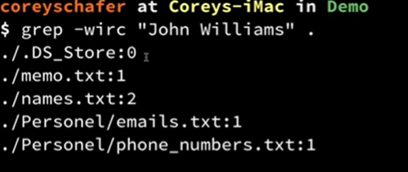

**You can also use grep with combination of history command to find text. Combination of 2 commands is achieved using | (pipe separater)**

**As you can see below history command returns all the commands that were performed on the machine but grep will filter it out further to get results which contain git commit text and dotfile text**

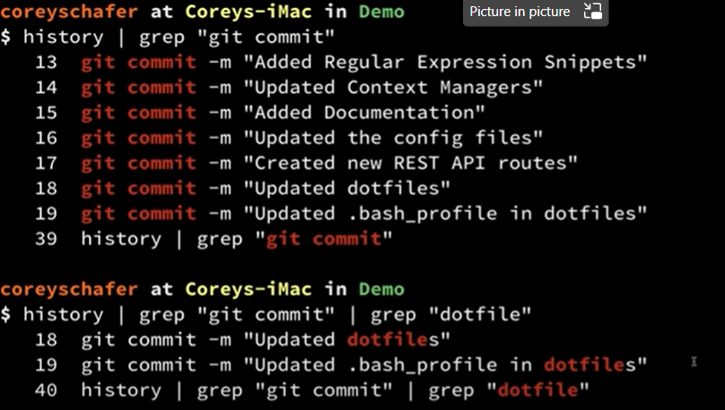

**LS**

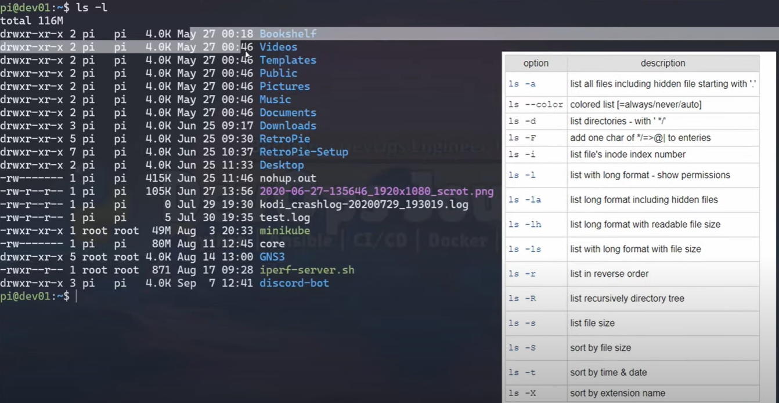



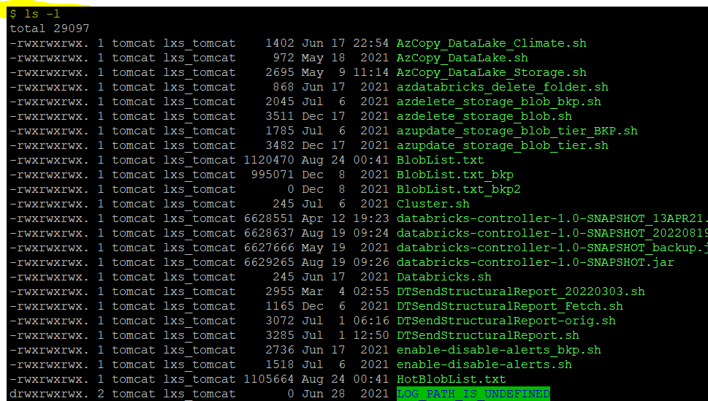

**-t in sorted time date**

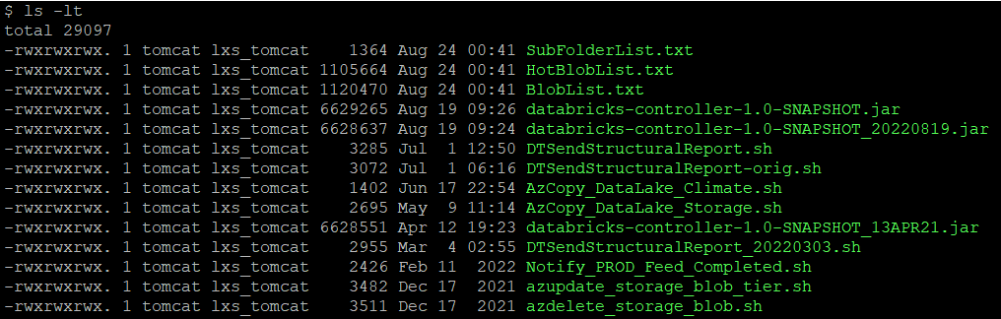

**-r reverse order**

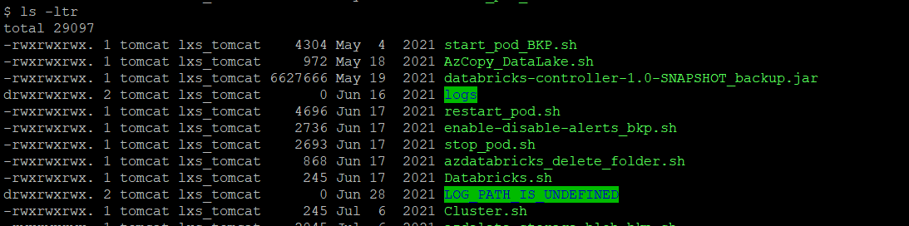

**Change password**

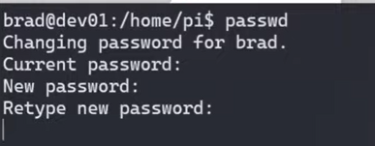

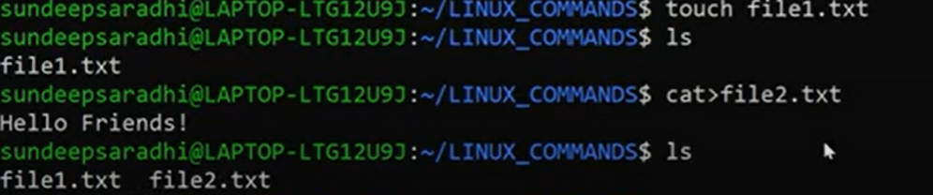

**Tac command displays file in reverse order**

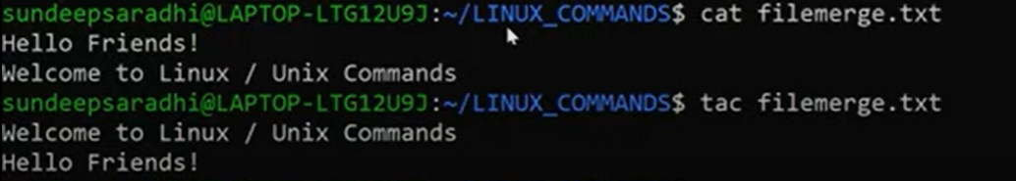

**More command used to display large content file and scrolls down by pressing enter or spacebar**

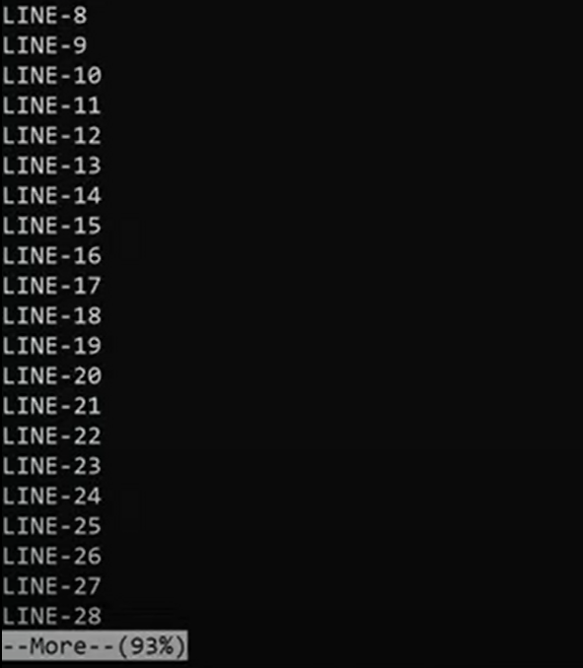

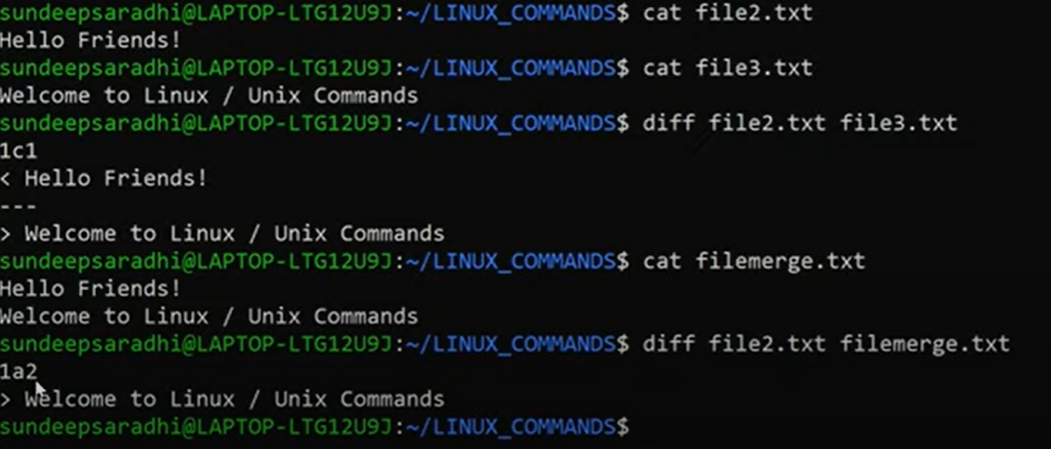

DISPLAY FILE CONTENT WITH LINE NUMBER

